Module Name: Requirement Review / Walkthrough / Inspection
Test Case ID: 3
Webpage URL: https://www.demoblaze.com/

- Scenario ID: 1

Scenario: View Products
Test Steps:
1. Open Website
2. Go to categories
3. And view product
Screenshot: 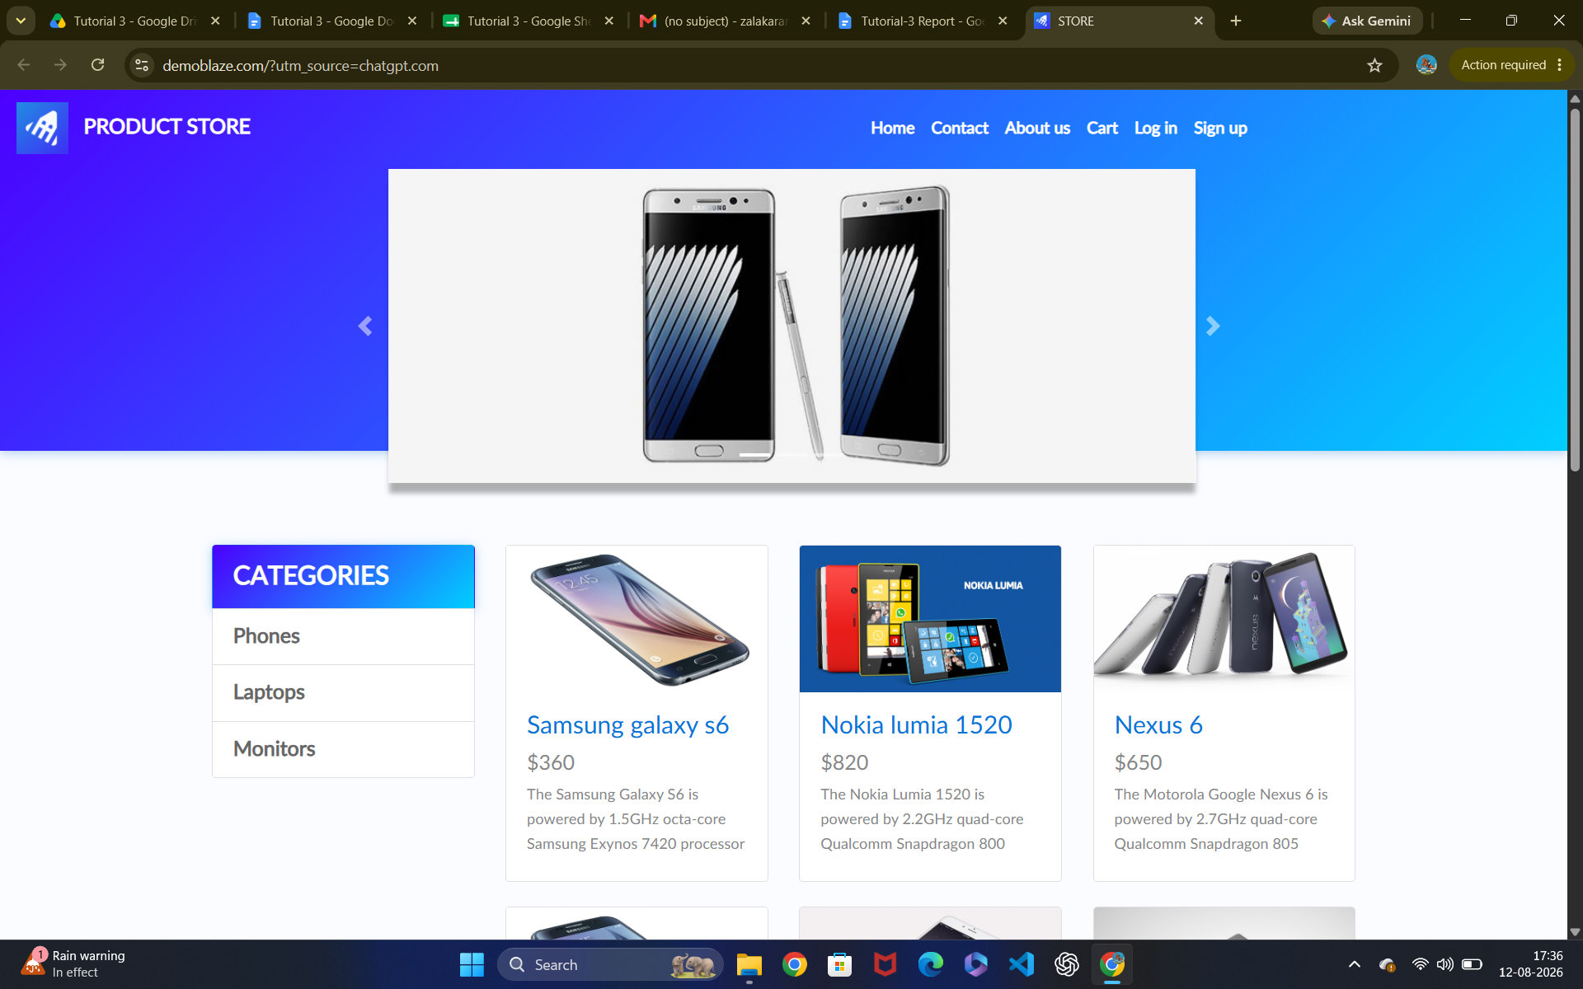Scenario ID: 2

Scenario: Select Products
Test Steps:
1. Select Product you want
Screenshot: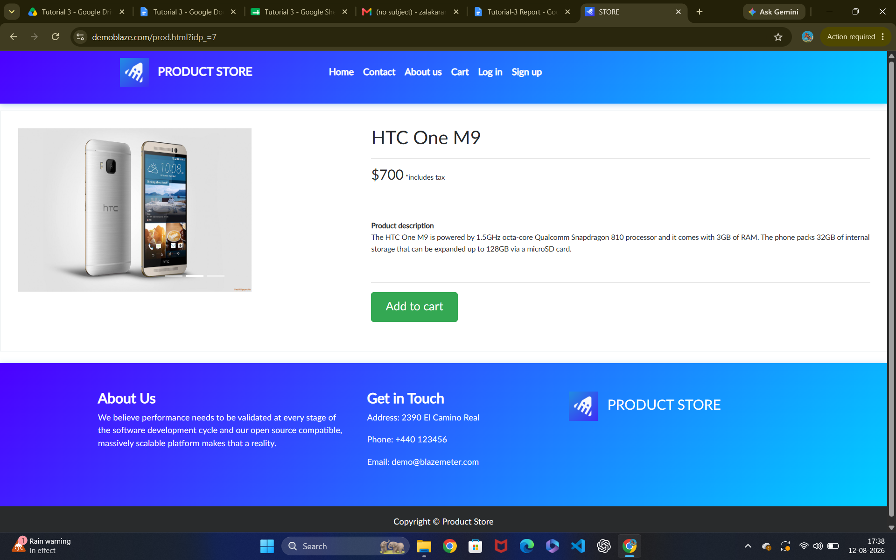Scenario ID: 3

Scenario: View Product details
Test Steps:
1. Tap on product details
2. Product Details
Screenshot:
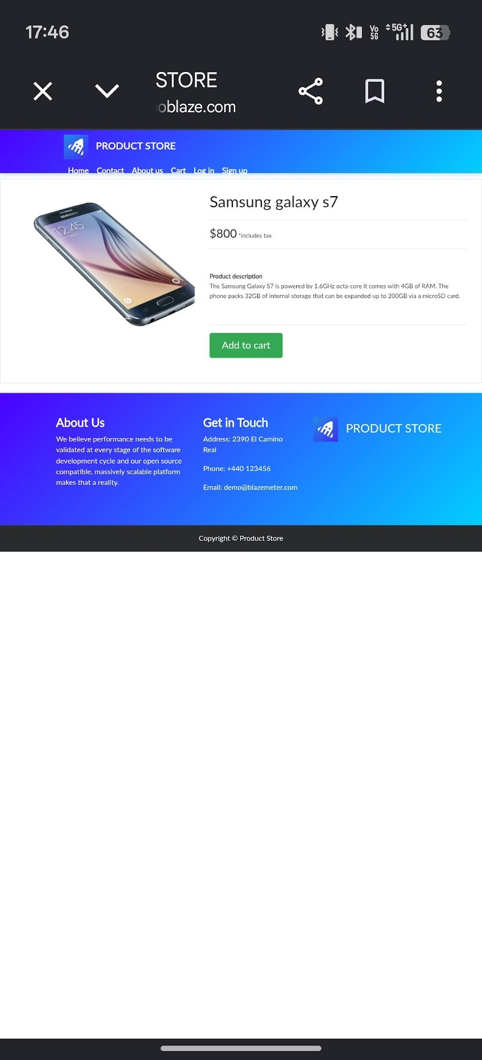

- Scenario ID: 4

Scenario: Add Product
Test Steps:
1. Add to cart
Screenshot: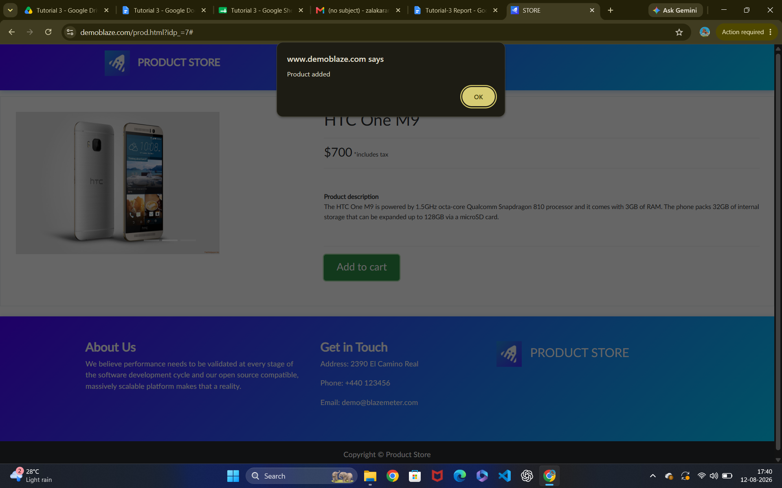Scenario ID: 5

Scenario: Open cart
Test Steps:
1. Tap on Cart icon
Screenshot: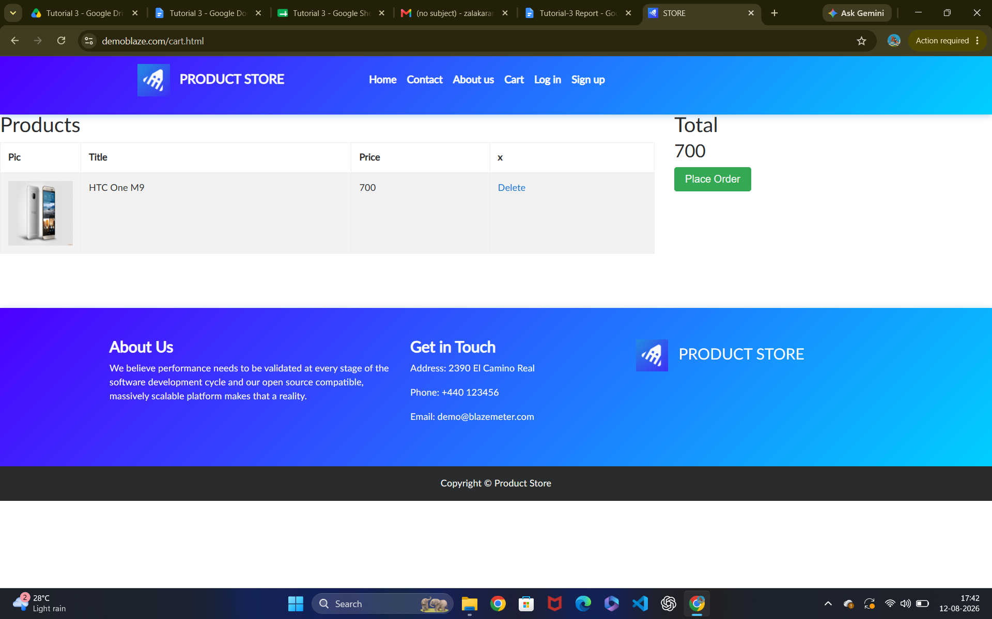

Scenario ID: 6

Scenario: Verify Product in cart
Test Steps:
1. Check the added item

Screenshot:

Scenario ID: 7

Scenario: View Products
Test Steps:
1. Tap on delete icon

Screenshot:

